**Lab 4 & 5**

**Weightage: 10%**

Course: COMP301 SEC406

Student Name: Joseph Ang

Student Number: 301354600

Table of Contents

1. Create a bash script that takes a list of numbers as input and prints the sum and average of all the even numbers in the list. 2

2. Set up a cron job to run a script named backup.sh every day at 2:00 AM, which backs up a specific directory to another location. 4

3. Write a C program to find the factorial of a given number using recursion. 6

4. Implement a binary search algorithm in C++. 8

5. How do you change the default SSH port in CentOS? 10

**Write the code and share the output for each task.**

1. Create a bash script that takes a list of numbers as input and prints the sum and average of all the even numbers in the list.

1. Set up a cron job to run a script named backup.sh every day at 2:00 AM, which backs up a specific directory to another location.

This is the backup.sh script that will be run everyday

This is in crontab -e to setup the cron

1. Write a C program to find the factorial of a given number using recursion.

1. Implement a binary search algorithm in C++.

1. How do you change the default SSH port in CentOS?

First we check what the default ssh port is on my centos.

So now we know the default port is 22.



We then use this to add in port 1075 to change the default port to port 1075

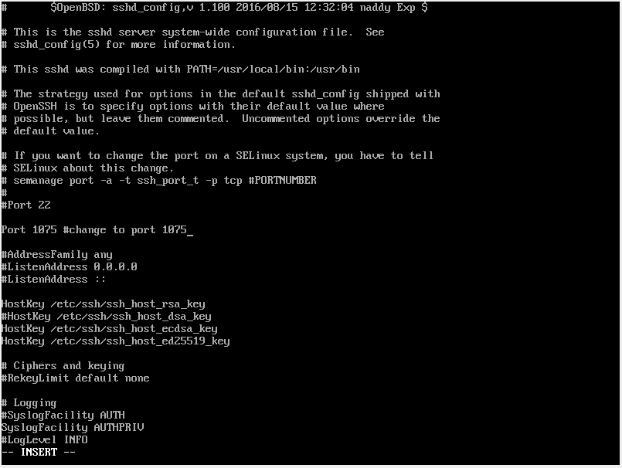

Port 1075 is added below the default that is set to 22

Then I use semanage to define the port to daemon and then I restart and check to ensure that the port is now changed to Port 1075.